The manufacturer Portable Multimedia Limited trading as Nextbase
Address Nextbase, Floor 6, 230 Blackfriars Road, London, SE1 8NW
EU Representative AR Experts, PO Box 5047, 3620 AA Breukelen, The Netherlands
Declares under sole responsibility that the product:
Product Name | REAR WINDOW CAMERA
Model Number
  NBDVRS2RWC

Is in conformity with the relevant Union Regulations: | The following relevant harmonised standards and/or relevant standards / regulations have been applied:
2014/30/EU (EMC)
  EN 55032:2015
  EN 55035:2017
  IEC 61000-4-2:2008
  IEC 61000-4-3:2006+A1:2007+A2:2010
  IEC 61000-4-4:2012
  IEC 61000-4-5:2014
  IEC 61000-4-8:2009
2014/35/EU (LVD) | EN 62368-1:2014+A11:2017
2011/65/EU + 2015/863  (RoHS Directive) | IEC 62321
EC 1907/2006 (REACH) | SVHC/Annex XVII
This product complies with the requirements above and carries the CE mark accordingly.
It has been certified under the “worst case scenario” tests performed on the NBDVR522X.

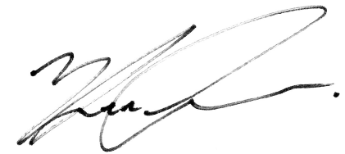
Portable Multimedia Limited,
Caerphilly, Wales,
23rd November 2023
Mr. Keelan O’Connor
Quality & Compliance Manager

